Lab 1: Overview of Network Wire and Equipment

Objective:

* To Identify Cable standards
* To Use Wiring equipment like clampers, testers, wires and connectors
* To Create and test cross over and straight through cables

Theory:

* Describe the theories of TIA/CIA 568A and 568B standards for construction of cross over and straight through cables.
* Describe the theory of RJ45 jack.

Procedure:

* List the procedure that has been done in the class.

Conclusion:

* Conclude the lab sheet with conclusion.

Lab 2: To configure the IP address of the computer windows client

Objective:

* To configure the IP address of the computer windows client
* To assign static IP address using the settings

Procedure:

To configure the IP address of the computer windows client

1. Open control panel
2. Click on network and internet
3. Click on networking and sharing center
4. Click the change adapter settings option on the left navigation pane
5. Right click the network adapter and select the properties option
6. Select the Internet Protocol Version 4 (TCP/IPv4) option
7. Select the IP version and click the properties button
8. Select the ‘use the following IP address’ option
9. Set the IP address as per your roll number (192.168.20. roll no)
10. Set the subnet mask to be 255.255.255.0 (it’s usually used in home network)
11. Set the default gateway. Default gateway is the IP address of your router. (list the IP used by consulting lab technician)
12. Under the ‘use the following DNS server address, set preferred DNS server” section, set the preferred DNS server address which is manually router’s IP address or the IP address of the server providing DNS resolution. (list the IP used by consulting lab technician)
13. Click the OK button
14. Click the close button
15. Observe if your internet works

To assign static IP address using settings

1. Open setting
2. Click on network and internet
3. Click on ethernet
4. Click on network connection
5. Under the ‘IP setting’ section, click on the edit button
6. Using the drop down menu, select the manual setting
7. Turn on the IPv4 toggle switch
8. Set the IP address as per your roll number (192.168.20. roll no)
9. Set the subnet mask to be 255.255.255.0 (it’s usually used in home network)
10. Set the default gateway. Default gateway is the IP address of your router. (list the IP used by consulting lab technician)
11. Set the preferred DNS server
12. Set the alternative DNS address if applicable
13. Click the OK button
14. Click the close button
15. Observe if your internet works

Conclusion:

* Conclude the lab sheet with conclusion.

Lab 3: To Create a basic network and share files and folders

Objective:

* To create a basic network and share files and folders
* To share files with specific users only

Procedure:

(To create a basic network and share files and folders

1. Right click the item and select the properties option
2. Click on the sharing tab
3. Click on the share button
4. Use the drop down menu to select the user or group to share a file or folder
5. Click the add button
6. Under the ‘permission level’ selection, select the sharing permission you want to the folder to have. For example, you can select read if you only want users to view and open files. If you select read/write then users can view, modify and delete the content on the folders you are sharing
7. Click the share button
8. Confirm the folder’s network path that other users will need to access the network’s content and click the done button
9. Click the close button

To share files with specific users only

1. Right click the item and select the properties option
2. Click on the sharing tab
3. Select the everyone group and click remove button
4. Click add button
5. Type the name of the user you want to share files with
6. Click the check name button
7. Click the ok button
8. Select the user account and you will notice that the “read Permission” is checked by default
9. If you want the user to be able to edit, delete and create new files, make sure to also check the change permission option
10. Click the apply button
11. Click the ok button

Conclusion:

* Conclude the lab sheet with conclusion.

Lab 4:

Objective:

* Create a Peer to Peer network

Equipment needed:

* 2 work station
* 1 ethernet cable (cross cable)

Procedure:

* Connect the stations with the cross cable
* Configure the IP address of each PCs as
  + PC1: 192.168.10.1
  + PC2: 192.168.10.2
* To verify connectivity ping one pc from the other using command
  + Ping (192.168.10….)
* Also try to share folder and check

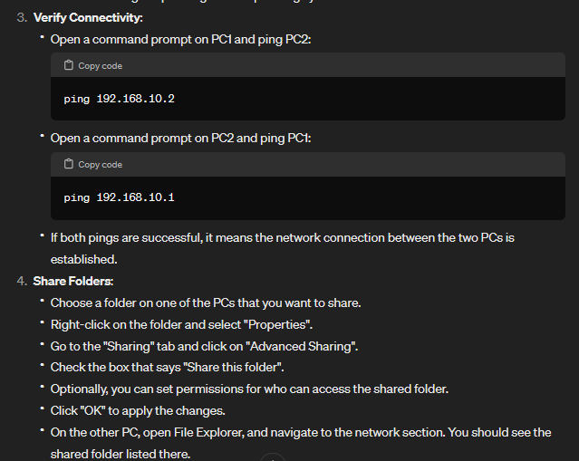Chatgpt:

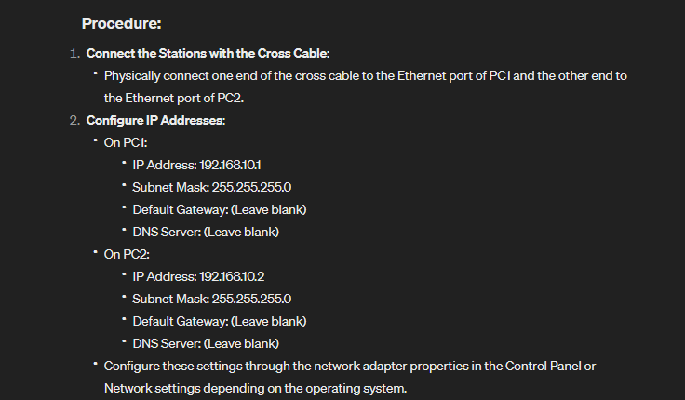

Conclusion:

* Conclude the lab sheet with conclusion.

Lab 5:

Objective:

* Familiarization with basic Linux commands

Lab 5:

Objective:

* Familiarization with basic Linux commands

Procedure:

* Learn and use the following commands
  1. #ip link (for new NICS)
  2. #cd/etc/sysconfig/network_scripts/ 🡨 #ls (Assign IP address on a NIC)
  3. #viconfig-enp0s3 🡨 1 🡨 click esc and type :wq to save 🡨 #systemctl restart network 🡨 #ifconfig (Assign IP address using DHCP)
  4. #route – u 🡨 #systemctl restart network 🡨 #ifconfig 🡨 #ping192.168.20.200 (Assign IP address statically)
  5. #hostname 🡨 #hostnamectl 🡨 #hostnamectl set_hostname server.example.con (view current hostname and change current hostname)

Observation:

* Describe and illustrate what and why the above commands were used

Conclusion:

* Conclude the lab sheet with conclusion.

Lab 6:

Objective:

* Familiarization with windows networking commands

Procedure:

* Learn and use the following commands
  1. ipconfig
  2. ping
  3. tracert
  4. netstat
  5. nslookup
  6. arp
  7. route
  8. net
  9. getmac
  10. pathping
  11. systeminfo

Observation:

* Describe and illustrate what and why the above commands were used

Conclusion:

* Conclude the lab sheet with conclusion.